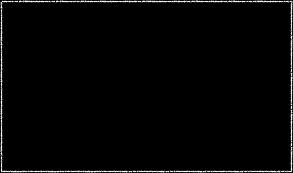
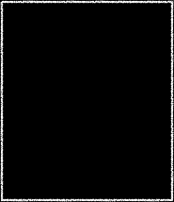
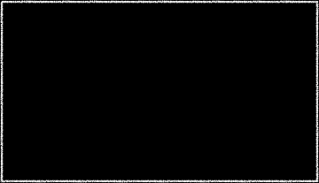
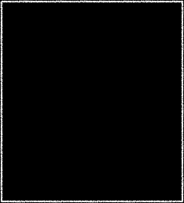
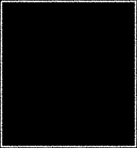
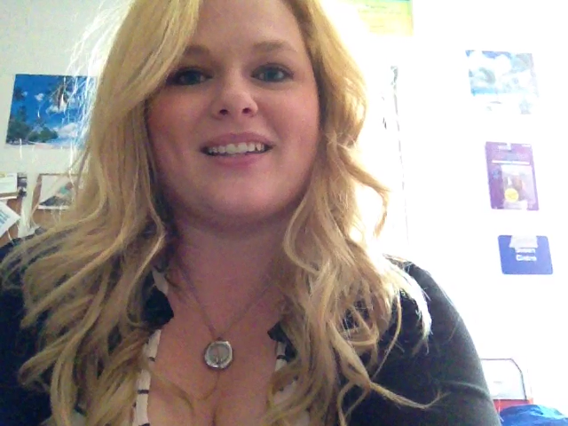

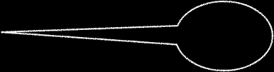




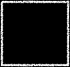
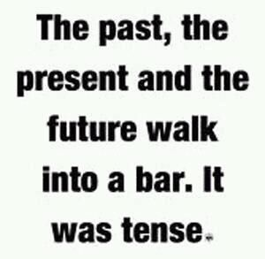
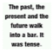
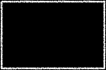


Welcome
In this course, you will be challenged by taking your understanding of fiction and nonfiction to a new level and begin to focus your analysis on what tools the authors use to create the specific impacts on the audience. Along with this comes with delving into literary criticisms, rhetorical analysis, and the inner workings of our own mind’s eye to discover the secrets and powers of the written word. All that in 36 weeks! Get ready! It’s going to be a wild ride!
Things you should know:
This is an EOC (END OF COURSE) Class which means that your FINAL EXAM IS 20% OF YOUR ENTIRE GRADE! Because of this, our grades work differently. Each 9 weeks counts as 20% with the EOC test completing the last 20%. This test occurs in the last month of school and this test was created by the makers of the ACT so the style of questions and timed nature of the test are similar. Because of this we will focus some on testing strategies, but we won’t be overwhelmed by them.
Grading scale: We follow the same 10 point scale as the school (i.e., 90-100 is an A and so on). In my class, 90% of your grade is Summative Assessment and 10% of your grade is Formative Assessment. Summative includes tests, essays, and projects, while formative is homework assignments, reading assignments, grammar, etc.
I grade on mastery level: You will receive a 5 for work that is Beyond Mastery, 4 is mastery, 3 is approaching mastery, 2 is partial mastery, 1 is non mastery, 0 is no evidence. This will be reflective in the formative assessment.

Supplies:
Internet Access: You WILL be required to complete work outside of class online and there is NO EXCUSE for not having this work completed. It’s the 21st century people...got to get in the game! If you don’t have access at home, there are local libraries that do; our school labs open at 7:45; my room will be open until 4 on Wednesdays. Find a way.
Google Drive account (we will use this for submitting ALL WRITTEN ESSAYS)
A stylus: This is not necessary but is recommended due to the nature of the tech in the class. We use iPads daily and some of the apps work better with a stylus.
Headphones: again not necessary but very helpful when watching videos on iPads which will happen frequently.
A microfiber cloth: The screens get really nasty and cleaning before use is advised. (I’ve gotten pink eye twice after updating them...)
1 box of tissues and 1 container of hand sanitizer or Clorox wipes. I have 3 little kids who get sick easily as do I and missing school for anyone is not a good idea!
Technology:
I’ve been fortunate enough to receive a grant that awarded my a cart of iPads for my classroom. We will be using these iPads on a daily basis and it is my goal that we will be a PAPERLESS class this year. That means, everything you submit to me will be done so digitally via our Google Drive accounts and possibly our Dropbox accounts (I’m in the midst of a shift between DropBox and GoogleDrive and that may develop more over the year, we shall see). So, this is going to be a bit of a change for several of you, but we will take time to work through these issues together. Also note that using the iPads is a privilege and if you break ANY of the rules that we will discuss in depth with the iPads, you will no longer be aloud to use them and therefore will forfeit all assignments that the iPads require. If you have your own iPad you would like to use, that is acceptable too however when the iPad is in my room, the same rules apply to it as to mine. No deviation from my rules can be made regardless of whose device it is.
On-Going Assignments and Responsibility:
You will have several on-going assignments. These are assignments that will be given at a certain time and that you are expected to be working on outside of class, but I will NOT remind you of them. It is YOUR RESPONSIBILITY to be ORGANIZED to keep up with these assignments on your own. As of right now, these are the on-going assignments, but more may come into play as the year progresses.
Poetry Sets: These will be given every 3 weeks continuously throughout the year.
Blogs: You will create your own blog via Blogger that is completely your brain child. This will be on the public domain, as all your work is, and it must be appropriate. More details will be given when this assignment begins.
Work with Jessamine County. Continuously throughout the year you will be working with East Jessamine HS on several projects.
All of this work is outside of class and your
own responsibility.
Other Mumbo Jumbo:
Late Work Policy: Same as the school so check the handbook HOWEVER don’t ask me for assignments when you’ve missed them, GO DIRECTLY TO THE WEBSITE. If further instruction is needed, see me.
Hall Pass: you can’t leave the room unless you have the school issued hall pass. If this hall pass goes missing, so do everyone else’s chances of leaving the class.
What this class looks like daily: Come in, get your iPad, do your BellWork, do your DGP, review DGP, begin lesson for the day, end in discussion or group work. The beginning will never change so get used to it!
“Becoming is superior to being.”--Paul Klee
PreAP English II 2014-2015
Susan Cintra, 859-625-6109 ext 5548
susan.cintra@madison.kyschools.us
www.cintrasclass.weebly.com
@cintrizzle

